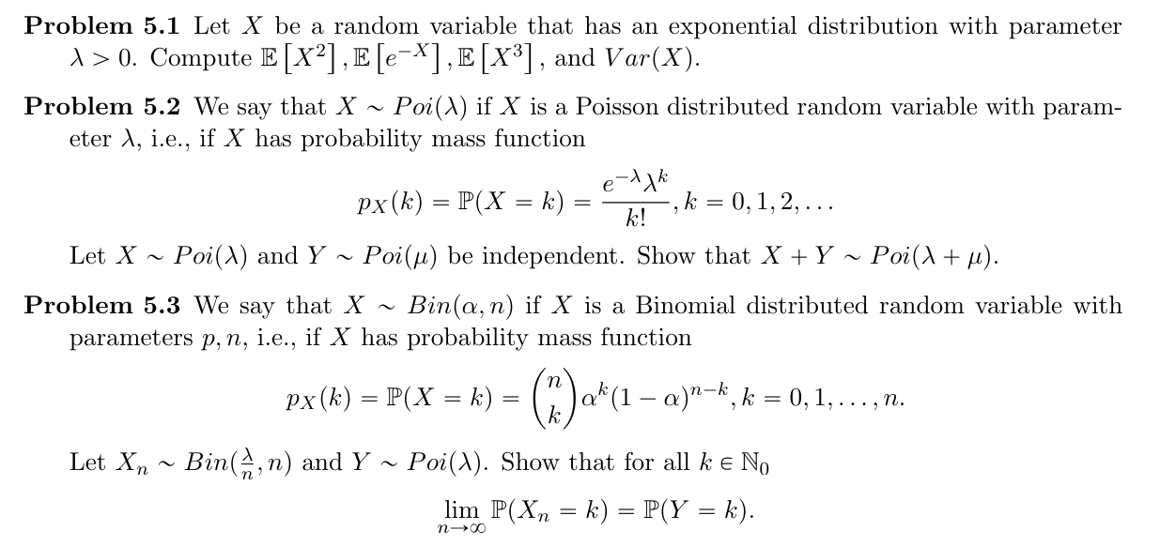

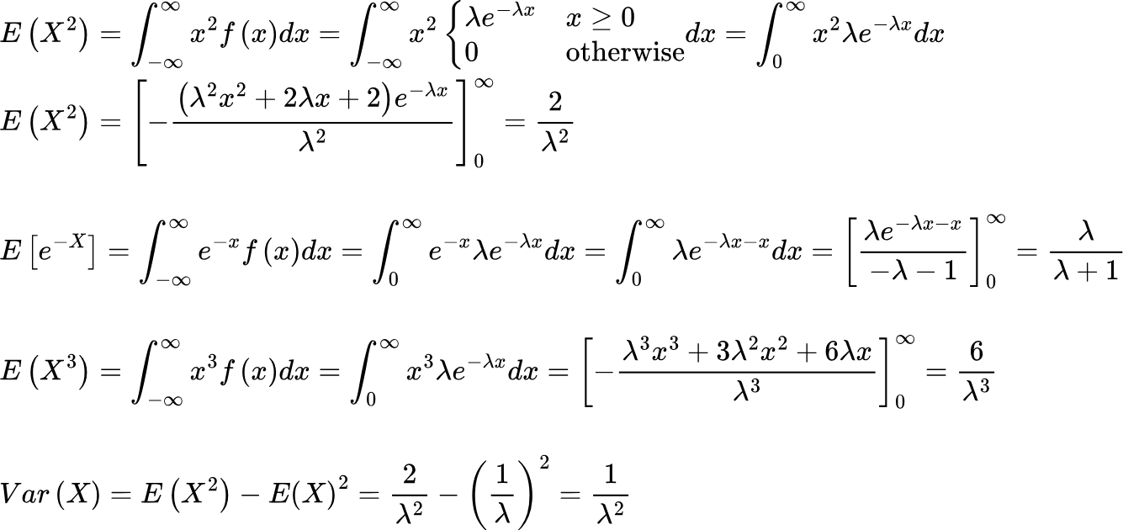

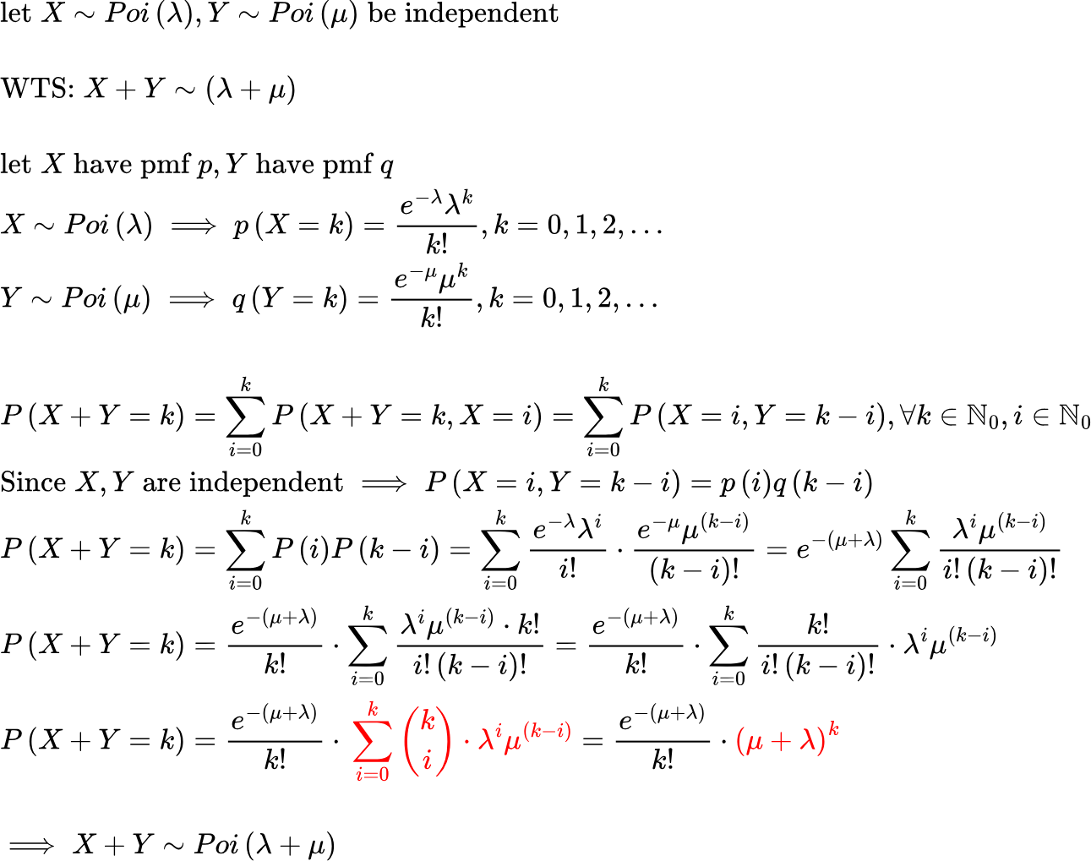



{"code":"\\begin{lalign*}\n&{\\text{let}\\;X_{n}\\sim \\text{Bin}\\left(\\frac{\\lambda}{n},n\\right),\\,Y\\sim \\text{Poi}\\left(\\lambda\\right)}\\\\\n&{}\\\\\n&{\\text{WTS:}\\;\\lim_{n\\to \\infty}P\\left(X_{n}=k\\right)=P\\left(Y=k\\right)}\\\\\n&{}\\\\\n&{\\text{pmf}\\;\\text{of}\\;X_{n}\\text{:}\\;p_{X}\\left(k\\right)=P\\left(X_{n}=k\\right)=\\binom{n}{k}\\left(\\frac{\\lambda}{n}\\right)^{k}\\left(1-\\frac{\\lambda}{n}\\right)^{n-k},k=0,1,...,n}\\\\\n&{Y\\sim Poi\\left(\\lambda\\right)\\implies \\text{pmf}\\;\\text{of}\\;Y:P\\left(Y=k\\right)=\\frac{e^{-\\lambda}\\lambda^{k}}{k!},k=0,1,2,...}\\\\\n&{\\lim_{n\\to \\infty}P\\left(X_{n}=k\\right)=\\lim_{n\\to \\infty}\\left(\\binom{n}{k}\\left(\\frac{\\lambda}{n}\\right)^{k}\\left(1-\\frac{\\lambda}{n}\\right)^{n-k}\\right)=\\lim_{n\\to \\infty}\\left(\\left(\\frac{n!}{\\left(n-k\\right)!\\cdot k!}\\right)\\left(\\frac{\\lambda}{n}\\right)^{k}\\left(1-\\frac{\\lambda}{n}\\right)^{n-k}\\right)}\\\\\n&{\\lim_{n\\to \\infty}P\\left(X_{n}=k\\right)=\\frac{\\lambda^{k}}{k!}\\cdot\\lim_{n\\to \\infty}\\left(\\left(\\frac{n!}{\\left(n-k\\right)!}\\right)\\left(\\frac{1}{n}\\right)^{k}\\left(1-\\frac{\\lambda}{n}\\right)^{n}\\left(1-\\frac{\\lambda}{n}\\right)^{-k}\\right)}\\\\\n&{}\\\\\n&{\\lim_{n\\to \\infty}\\left(\\frac{n!}{\\left(n-k\\right)!}\\right)\\left(\\frac{1}{n}\\right)^{k}=\\lim_{n\\to \\infty}\\frac{\\left(n\\right)\\left(n-1\\right)\\left(n-2\\right)...}{\\left(\\left(n-k\\right)\\left(n-k-1\\right)\\left(n-k-2\\right)...\\right)\\cdot n\\cdot n}=1}\\\\\n&{\\lim_{n\\to \\infty}\\left(1-\\frac{\\lambda}{n}\\right)^{-k}=\\left(1-0\\right)^{-k}=1}\\\\\n&{}\\\\\n&{\\lim_{n\\to \\infty}P\\left(X_{n}=k\\right)=\\frac{\\lambda^{k}}{k!}\\cdot\\lim_{n\\to \\infty}\\left(1+\\c{ff0000}{\\left(-\\lambda\\right)}\\frac{1}{n}\\right)^{n}=\\frac{\\lambda^{k}}{k!}\\cdot e^{-\\lambda}}\t\n\\end{lalign*}","font":{"family":"Arial","size":10.5,"color":"#000000"},"type":"lalign*","aid":null,"backgroundColor":"#ffffff","id":"9","ts":1715493494686,"cs":"J75CUg7ezk6F2JdUUWKitQ==","size":{"width":700,"height":492}}

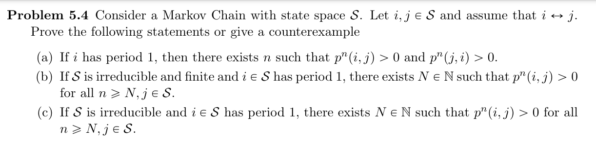

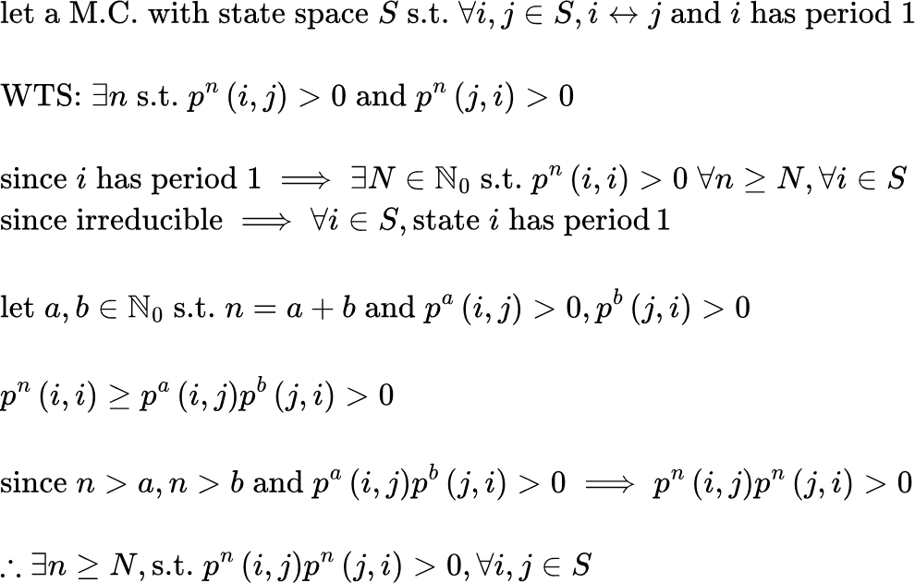



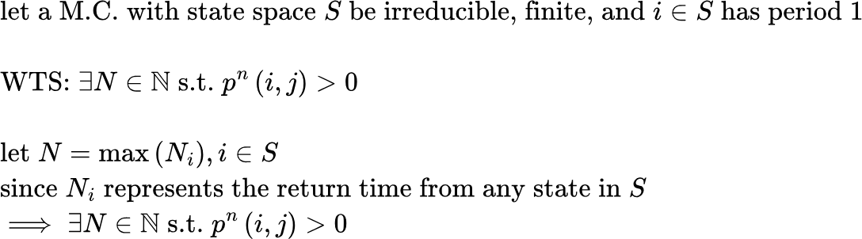



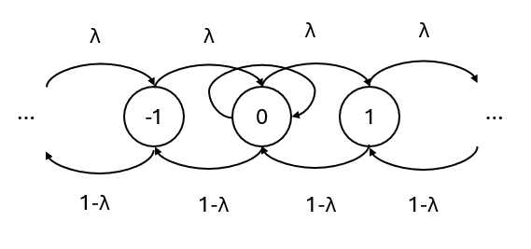

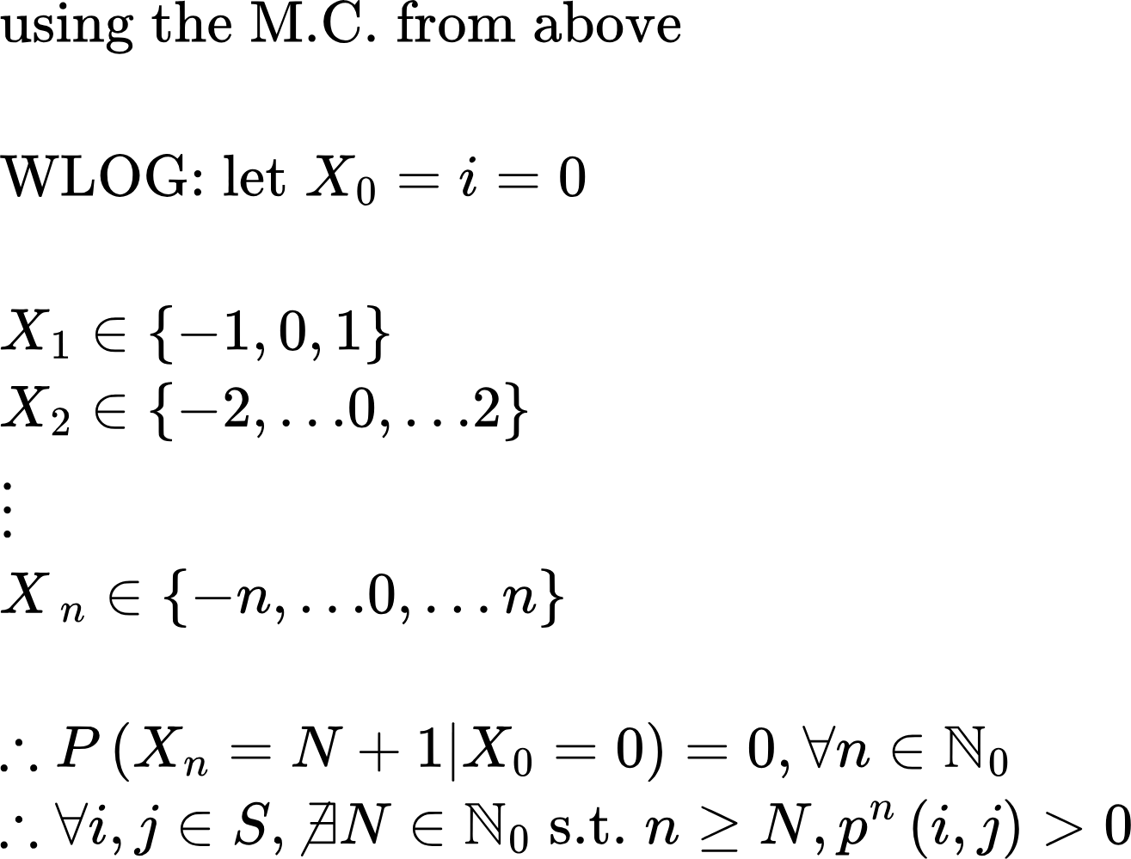

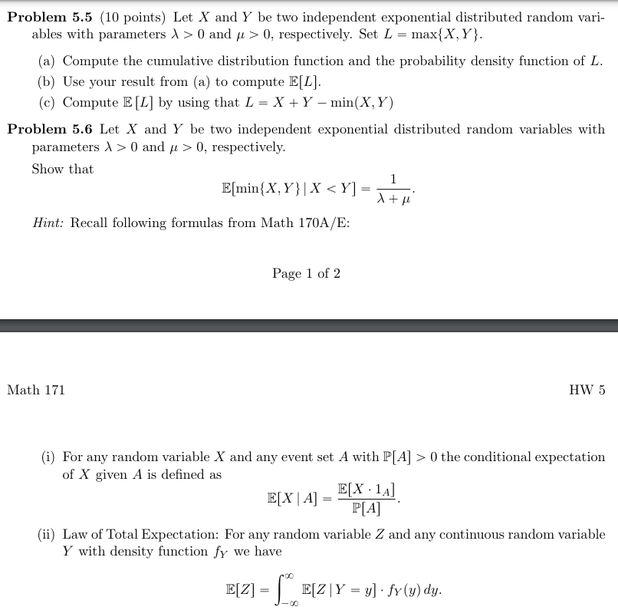

{"aid":null,"code":"\\begin{lalign*}\n&{X\\sim \\exp\\left(\\lambda\\right),Y\\sim \\exp\\left(\\mu\\right)\\;\\text{with}\\;\\lambda,\\mu>0}\\\\\n&{L=\\max\\left\\{X,Y\\right\\}}\\\\\n&{}\\\\\n&{P\\left(L\\leq l\\right)=P\\left(\\max\\left\\{X,Y\\right\\}\\leq l\\right)=P\\left(X<Y\\leq l\\right)+P\\left(Y<X\\leq l\\right)+P\\left(X=Y=l\\right)}\\\\\n&{P\\left(X<Y\\leq L\\right)=\\int_{0}^{l}\\mu e^{-\\mu y}dy\\cdot\\int_{0}^{y}\\lambda e^{-\\lambda x}dx=\\int_{0}^{l}\\mu e^{-\\mu y}dy\\cdot\\left[-e^{-\\lambda x}\\right]_{0}^{y}=\\int_{0}^{l}\\mu e^{-\\mu y}dy\\cdot\\left(-e^{-\\lambda y}+e^{0}\\right)}\\\\\n&{P\\left(X<Y\\leq L\\right)=\\int_{0}^{l}\\mu e^{-\\mu y}dy\\cdot\\left(-e^{-\\lambda y}+1\\right)=\\int_{0}^{l}\\mu e^{-\\mu y}\\left(-e^{-\\lambda y}+1\\right)dy=\\int_{0}^{l}\\left(\\mu e^{-\\mu y}-\\mu e^{-y\\left(\\mu+\\lambda\\right)}\\right)dy}\\\\\n&{P\\left(X<Y\\leq L\\right)=\\left[\\frac{\\mu e^{-\\left(\\mu+\\lambda\\right)y}}{\\mu+\\lambda}-e^{\\lambda y}\\right]_{0}^{l}=\\frac{\\mu e^{-\\left(\\mu+\\lambda\\right)l}}{\\mu+\\lambda}-e^{\\lambda l}-\\left(\\frac{\\mu e^{-\\left(\\mu+\\lambda\\right)\\cdot0}}{\\mu+\\lambda}-e^{\\lambda \\cdot0}\\right)}\\\\\n&{P\\left(X<Y\\leq L\\right)=\\frac{\\mu e^{-\\left(\\mu+\\lambda\\right)l}}{\\mu+\\lambda}-e^{\\lambda l}-\\frac{\\mu }{\\mu+\\lambda}+1}\\\\\n&{}\\\\\n&{\\text{by}\\;\\text{symm:}\\;P\\left(Y<X\\leq l\\right)=\\frac{\\lambda e^{-\\left(\\mu+\\lambda\\right)l}}{\\mu+\\lambda}-e^{\\lambda l}-\\frac{\\lambda}{\\lambda+\\mu}+1}\\\\\n&{}\\\\\n&{P\\left(L\\leq l\\right)=\\frac{\\mu e^{-\\left(\\mu+\\lambda\\right)l}}{\\mu+\\lambda}-e^{\\lambda l}-\\frac{\\mu }{\\mu+\\lambda}+1+\\left(\\frac{\\lambda e^{-\\left(\\mu+\\lambda\\right)l}}{\\mu+\\lambda}-e^{\\mu l}-\\frac{\\lambda}{\\lambda+\\mu}+1\\right)}\\\\\n&{P\\left(L\\leq l\\right)=\\frac{\\left(\\mu +\\lambda\\right)e^{-\\left(\\mu+\\lambda\\right)l}}{\\mu+\\lambda}-e^{\\lambda l}+-\\frac{\\mu +\\lambda}{\\mu+\\lambda}+2=\\frac{\\left(\\mu +\\lambda\\right)e^{-\\left(\\mu+\\lambda\\right)l}}{\\mu+\\lambda}-e^{\\lambda l}+1}\\\\\n&{\\text{CDF:}\\;P\\left(L\\leq l\\right)=1-e^{\\lambda l}-e^{\\lambda l}+e^{-\\left(\\mu+\\lambda\\right)l}=\\left(1-e^{-\\lambda l}\\right)\\left(1-e^{-\\mu l}\\right)}\\\\\n&{\\diff{}{l}\\left(\\left(1-e^{-\\lambda l}\\right)\\left(1-e^{-\\mu l}\\right)\\right)=\\left(\\diff{}{l}\\left(1-e^{-\\lambda l}\\right)\\right)\\left(1-e^{-\\mu l}\\right)+\\left(1-e^{-\\lambda l}\\right)\\left(\\diff{}{l}\\left(1-e^{-\\mu l}\\right)\\right)}\\\\\n&{}\\\\\n&{P\\left(X+Y=l\\right)=\\left(\\lambda e^{-\\lambda l}\\right)\\left(1-e^{-\\mu l}\\right)+\\left(1-e^{-\\lambda l}\\right)\\left(\\mu e^{-\\mu l}\\right)}\\\\\n&{P\\left(X+Y=l\\right)=\\lambda e^{-\\lambda l}+\\lambda e^{-\\lambda l}\\cdot e^{-\\mu l}+-\\mu e^{-\\mu l}+\\mu e^{-\\mu l}e^{-\\lambda l}}\\\\\n&{\\text{PDF:}\\;P\\left(X+Y=l\\right)=\\lambda e^{-\\lambda l}+-\\lambda e^{-\\left(\\mu+\\lambda\\right)l}+-\\mu e^{-\\mu l}+\\mu e^{-\\left(\\mu+\\lambda\\right)l}=\\lambda e^{-\\lambda l}+\\mu e^{-\\mu l}-\\left(\\mu+\\lambda\\right)e^{-\\left(\\mu+\\lambda\\right)l}}\\\\\n&{}\\\\\n&{}\t\n\\end{lalign*}","font":{"family":"Arial","size":10,"color":"#000000"},"type":"lalign*","id":"5","backgroundColorModified":false,"backgroundColor":"#ffffff","ts":1715494830365,"cs":"Irgxytxa0kRUwtOuSW8wOw==","size":{"width":678,"height":584}}



